Intensity_analyzer Instructions

This script takes in two images as input; lo_power and hi_power.

Here is a sample file naming format:

20140409_yw_cycB565lo.tif

and

20140409_yw_cycB565hi.tif

1. copy the files :

intro.fig  
intro.m

selectdata.m

tagwriter.m

analyze_intensity.m

intensity_analyzer.m into your working directory or place the folder containing the files in your MATLAB path by clicking ‘set path’ in the MATLAB toolbar, and setting the folder containing these files as a path.

Also make sure the folder containing Shawn’s code is in this path.

1. set the folder containing the image files as your working directory.
2. Run the script using the code “intensity_analyzer(‘name of image file before lo/hi’, ‘mRNA being investigated’)”

Eg. Intensity_analyzer(‘20140409_yw_cycB565’,’cycB’) ///Don’t forget that the parameters have to be in single quotation marks.

4. The script will generate a dialog box(see fig.1 below) prefilled with the information that is needed to populate the tag file. Change any data that is erroneous. The ones in red are the ones that you may likely want to edit sometimes. Click ‘Proceed’ to continue.

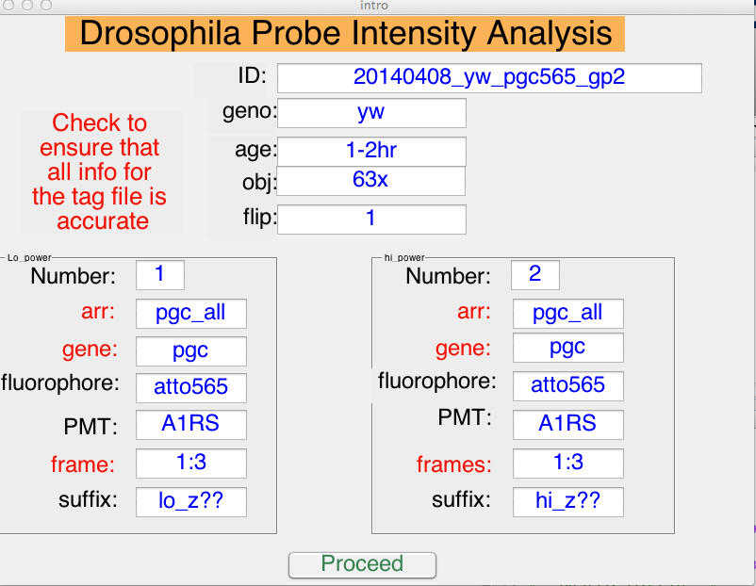

fig.1

1. After the script analyzes the image, it will present you with an interactive histogram (fig. 2 below). At the lower end of the histogram, there should ideally be a valley. Points with intensities below this threshold are spurious. Click a point in the valley to select a ballpark threshold dog intensity above which the spots are not spurious.

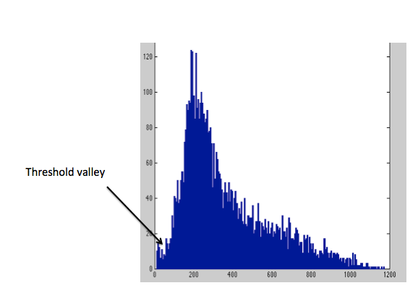Fig. 2

1. Next the script will calculate the scale by which the lo_power data has to be multiplied by to be comparable to the hi_power data. To facilitate this, the script will present an interactive plot….Look for a relatively straight line on the plot, and select two points along this relatively straight part of the graph.
2. Next, the germ plasm of both the hi_power and lo_power data will have to be delineated. This is done by again selecting a valley in the histogram of log of dog intensities. An interactive histogram(see fig.3) will be displayed, and you are to click within the valley in the histogram. (This will be done twice; one for hi-power data and then for lo_power data)

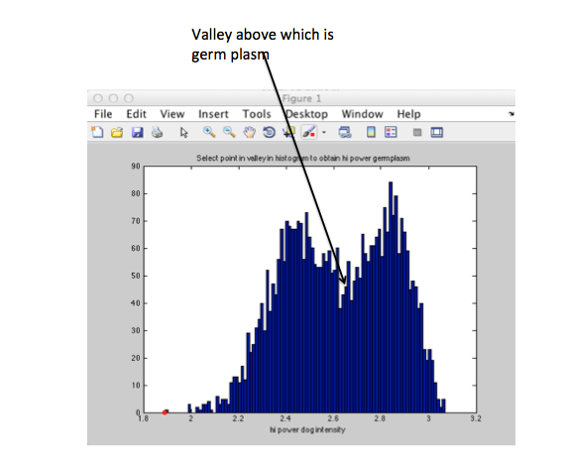

fig. 3

1. At the end, the script should display a histogram of the scaled lo_power germ plasm dog intensities divided by the average intensity from the bulk cytoplasm of the hi_power image (average no. of mRNA in germ plasm).

The range and mean of the average no. of mRNA in the germ plasm is also displayed.